HOBUCO PROFILE 2025
WHO WE ARE | HOBUCO Ltd established in the year 2016, is one of the multidisciplinary consulting firms in Rwanda that is goal oriented towards providing sustainable solutions to the challenges in the global consulting arena.
VISION, AND MISSION | Whereas our vision is to be a highly ethical and quality service provider to a vibrant private and/or public sector in Rwanda and abroad, HOBUCO’s mission statement is to provide a wide range of high-quality technical assistance and professional services essential for the development and implementation of viable business enterprises and development projects in a professional, timely and cost-effective manner.
OUR PARTNERS | - TerraFund for AFR100/ World Ressource Institute  - Commission Episcopale Justice et Paix- CEJP  - reNature Investments BV  - This SIDE Up
WHAT WE DO/ OUR SERVICES | Our key services stretch across:  - Research and experimental development in social sciences and humanities,  - Institutional capacity building, internal systems strengthening  - Baseline, midline and end-line evaluation for both private and public institutions,  - Policy and strategy formulation, procedure manuals and policies development  - Identification, design, appraisal, monitoring and evaluation of development projects  - Education support activities- development of training manuals  - Impact assessment surveneys, agroforestry and forestry, soil and water conservation engineering inclusive of land care projects,  - Management consultancy activities, trainings,  - Outcome harvesting/ Mapping  - Results based reporting  - Due diligence preparation  - Partner Capacity Assessment Survey (PCAS) tool  - Grant proposal development  - Support services to forestry,  - Wholesale of agricultural raw materials and live animals,  - Support services to forestry,  - Wholesale of agricultural raw materials and live animals,  - Other professional, scientific and technical activities.
OUR TEAM | 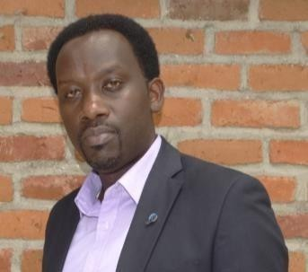  Dr. MPAYIMANA Fulgence  Telephone: +250788696388 Skype: fulgence. mpayimana Nationality: Rwandan  Age: 44 years  Marital status: Married  Managing Director  Dr.Fulgence MPAYIMANA  Rwanda, Kigali, Gasabo | + 250 788 696 388 | mfulgence2017@gmail.com  Dr. Fulgence MPAYIMANA [holding a PhD in Rural Development, is a seasoned development professional with over 15 years of expertise in Project Cycle management, Rural Development, Policy and Strategy formulation, Public Policy Analysis, Advocacy, NGOs Management, Climate Justice, Gender Mainstreaming, Youth and women's empowerment within the NGO Sector across Rwanda. His expertise extends to collaborating with national and International NGOs to impact the lives of vulnerable populations, particularly women and girls, across humanitarian and developmental contexts. Known for his adept leadership in fundraising, program management, and fostering gender equality, Dr. MPAYIMANA has a proven track record of achieving targeted outcomes and mobilizing resources effectively.  Notably, his experience spans various sectors including poverty reduction, child protection, gender promotion, youth empowerment and community development. His consultancy work with renowned organizations underscores his versatility and commitment to driving impactful change. Dr. MPAYIMANA's dedication and expertise make him an invaluable asset in any developmental endeavor related to social science and humanities. He successfully completed various assignments with organizations such as Commission Justice et Paix-CJEP, Rural Development Inter-Diocesan Services (RDIS), CRS, COCOF, CECI, PIASS, LODA, World Vision Rwanda, DUHOZANYE, AJPRODHO – JIJUKIRWA, COCOF, OXFAM Rwanda, NAEB, JESUIT URUMURI Centre, Plan International Rwanda among others.
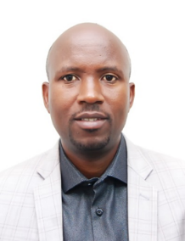
Deputy Managing Director
François Hakorimana is an environmental management specialist with over 10 years of experience in biodiversity conservation, land restoration, and climate resilience. Currently, he serves as the National Biodiversity Specialist at Enabel Rwanda, where he leads projects focused on enhancing community-based biodiversity conservation and reducing vulnerability to climate change in the Eastern Province. His expertise extends to landscape restoration and water management, having worked as a Water Management Officer for Rwanda’s Ministry of Agriculture, where he supervised watershed and irrigation projects. François also spent three years as the Landscapes Manager at the Albertine Rift Conservation Society (ARCOS), where he led projects that built climate resilience and promoted sustainable livelihoods across Rwanda’s Agro-ecosystems.

François holds an MSc in International Land and Water Management from Wageningen University and a MSc in Environmental Information Systems. He spent three years as a part-time lecturer at the University of Lay Adventists of Kigali, teaching Soil and Conservation, and integrating hands-on fieldwork into the curriculum. His research has focused on water efficiency in Tanzania and traditional irrigation practices in Spain. He is certified in project management, GIS, and environmental management, and has provided consultancy services as a data analyst for Africa Restoration Projects. Dedicated to promoting biodiversity, climate resilience, and sustainable development, I leverage my expertise in GIS, data analysis, and focuses on delivering community-centered, practical solutions to environmental challenges in Rwanda and beyond.
CONTACT US | Office Location: Muhanga District; Telephone: +250788696388 & +250 788 213 984, Email: hobucoltd2050@gmail.com

